Name: NGO TUNG CHUONG
ID: s225586848

YouTube: https://youtu.be/BUb6jNDrhN0?si=1RsAtkJAos2Tvsao
Github: https://github.com/NoXxChapter/SIT122---Robotics-Studio.git

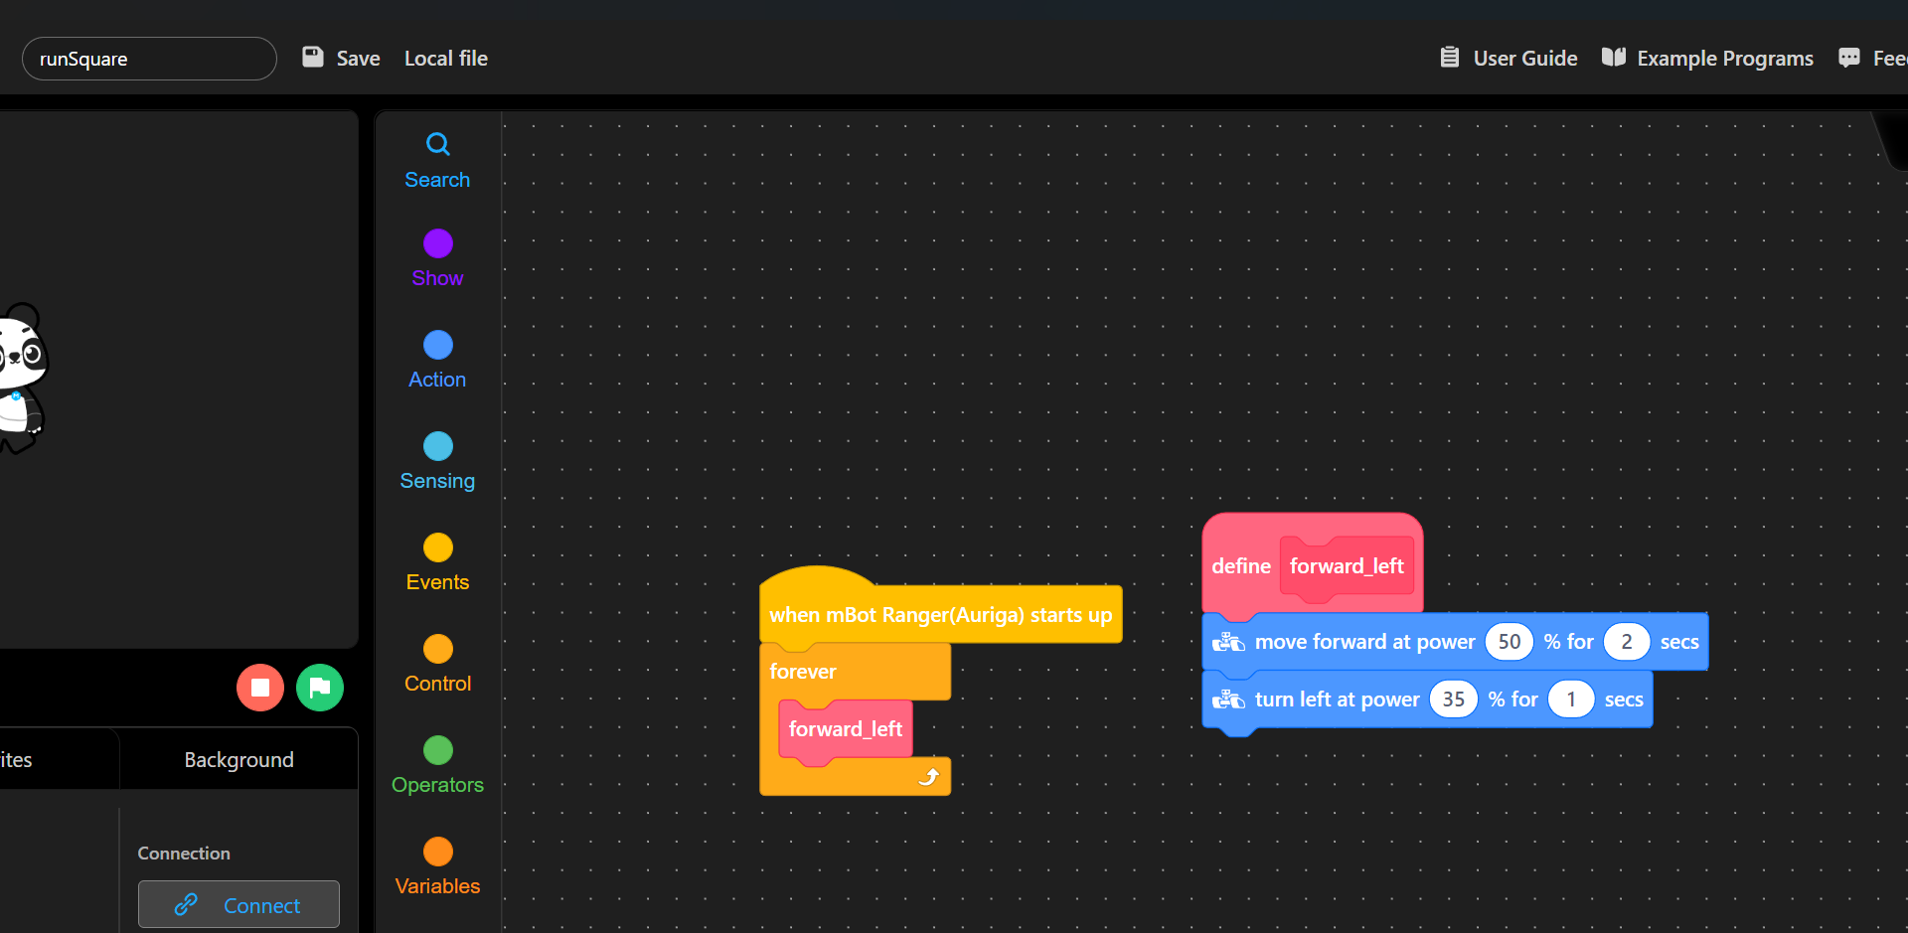
With this assignment, I decide to make the robot move in the straight line with 50% power in 2 seconds. Later turn left at 35% power for 1 second. The reasons, why reduce the speed and have a long interval like due to the easy of observation process. While also preserved the battery capacities.

